**B2B Travel Company**

Week – 7

1. Since, all the API’s which are required to present the real-time information about the services like flights, trains, buses, cabs and hotels are paid. So, it’s impossible for me to buy them that’s why I’ve created some basic examples for representing the data to the user.
2. Also, I’ve created the backend for integrating it with the frontend but due to unavailability of the API’s it’s not possible for me to run that one.
3. I’m attaching some pictures presenting that when you put the values of source and destination in the input field the result will be displayed to you.  
     
   **Note: Use example parameters only.**

**Flights:**

After filling all the details about the journey,

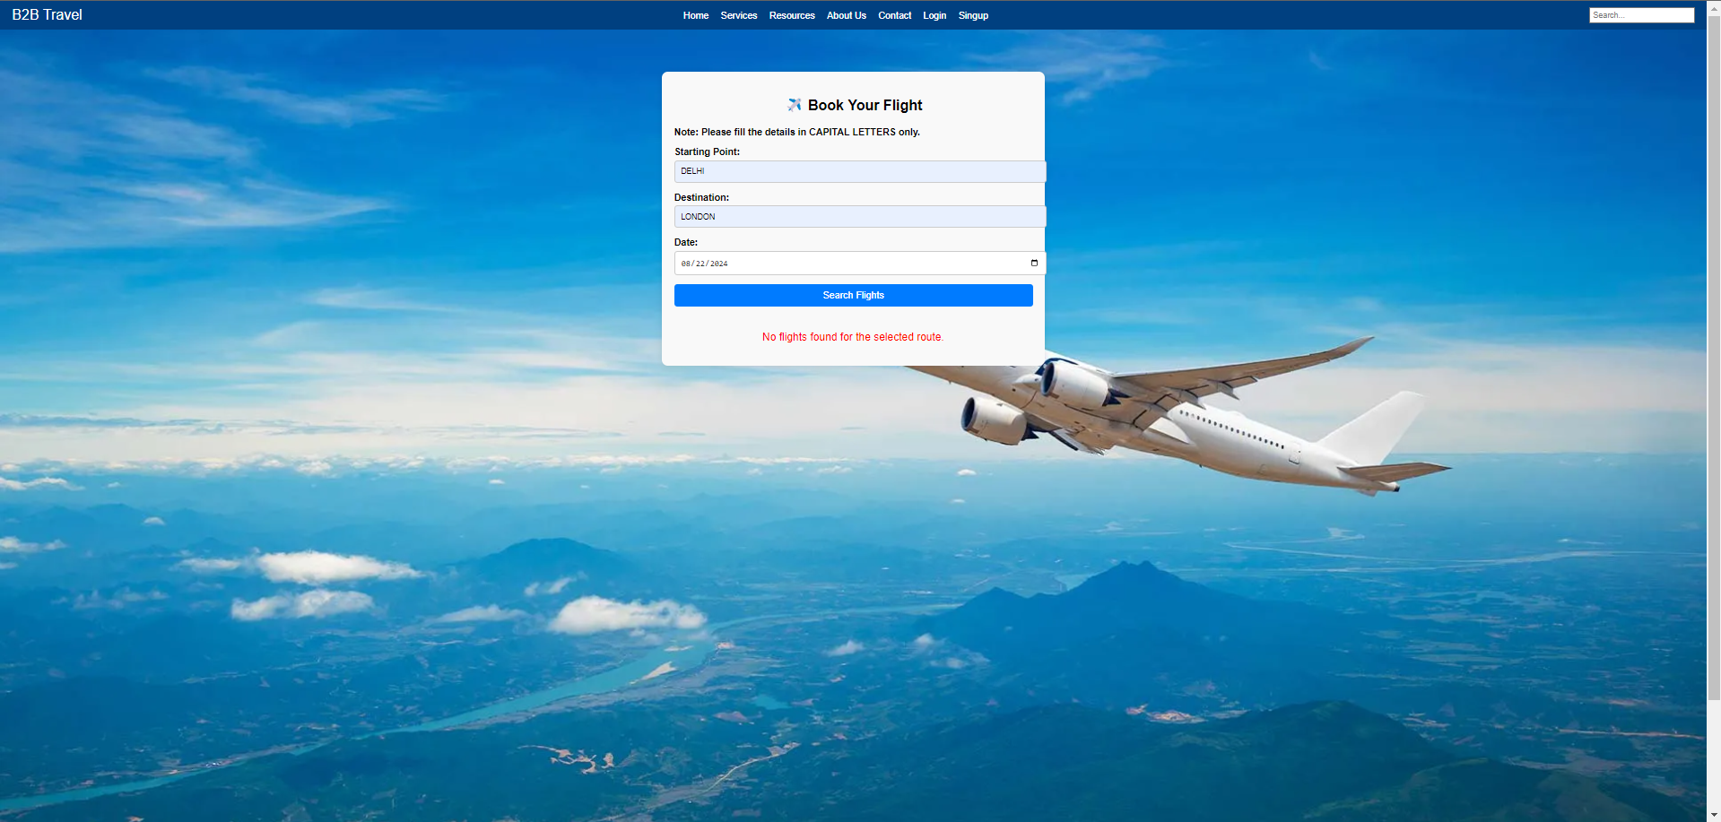

You will get the following result:

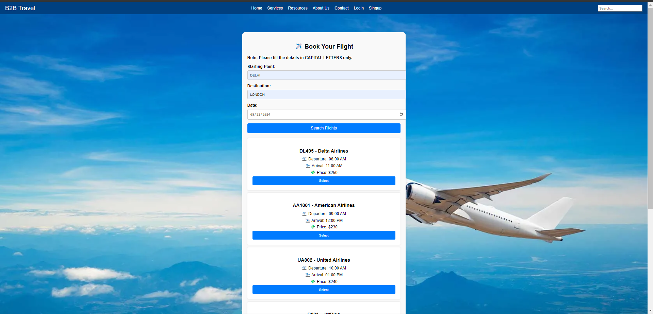

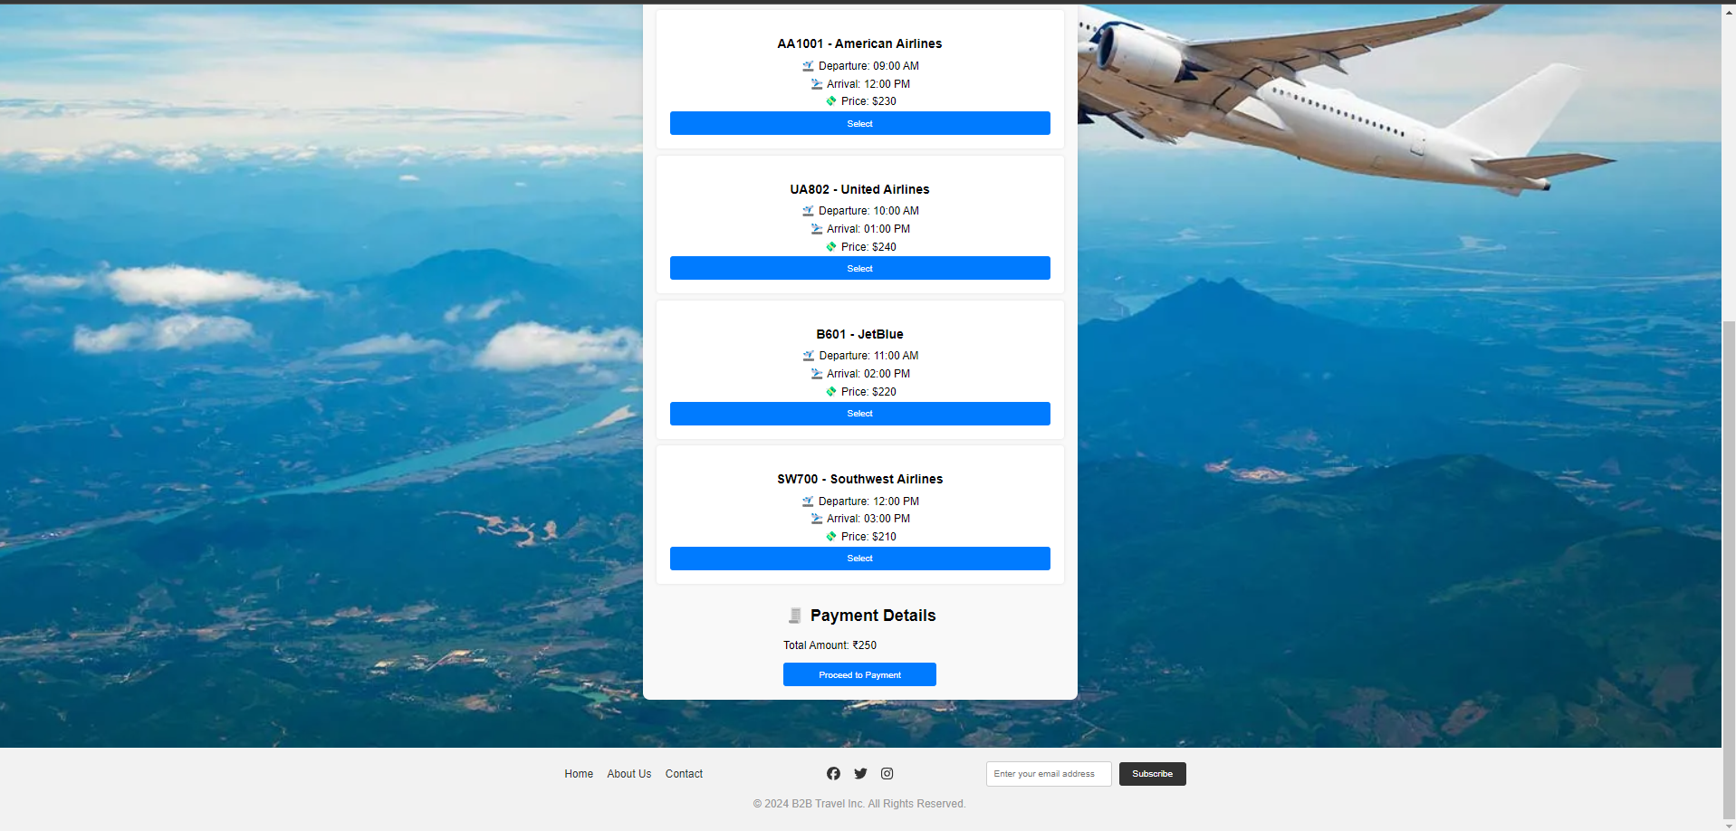

And here is the payment button also, but due to unavailability of RazorPay or any other payment gateway API, it will not work.

The same procedure will follow for all of the services.

**Trains:**

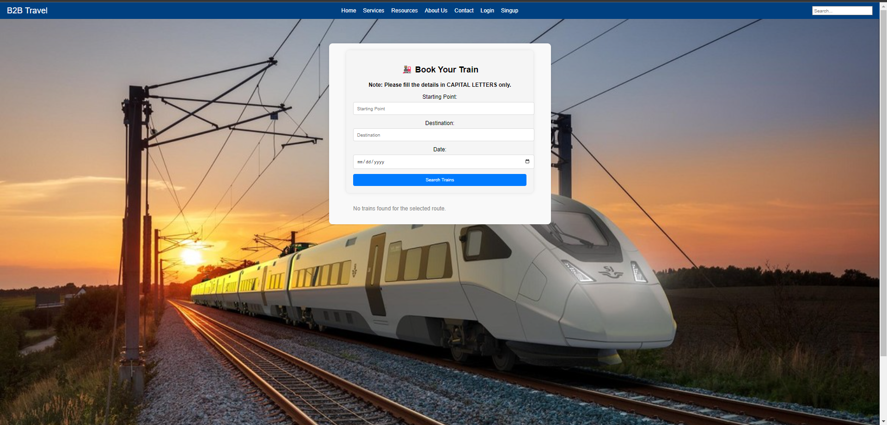

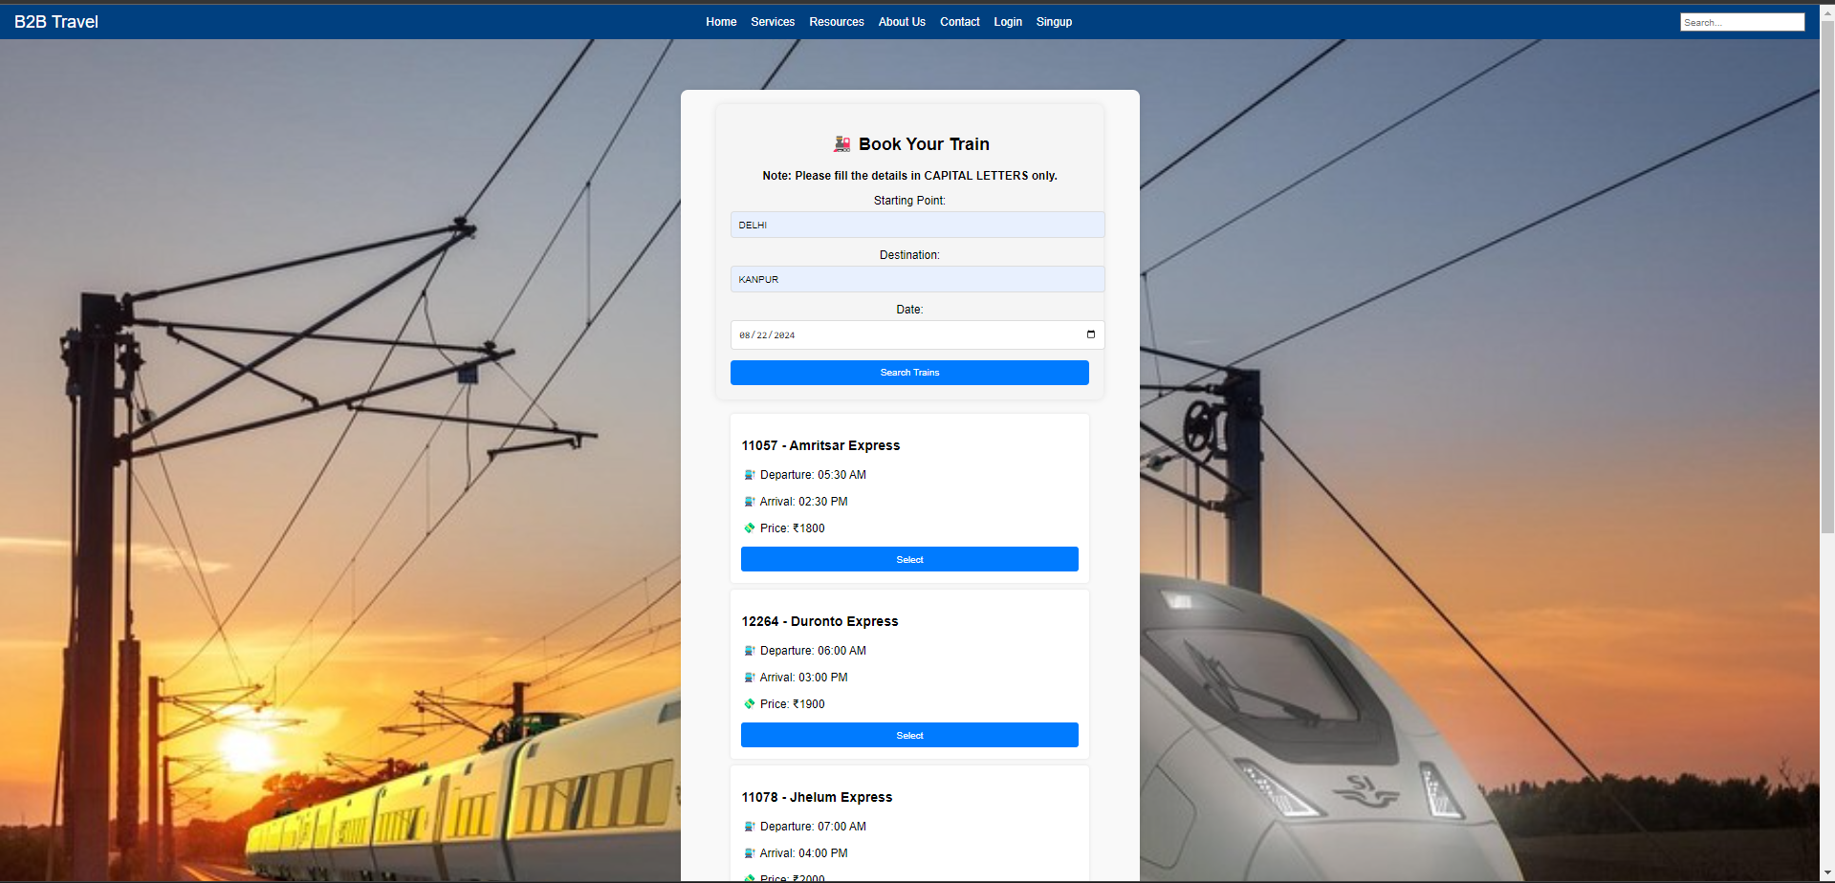

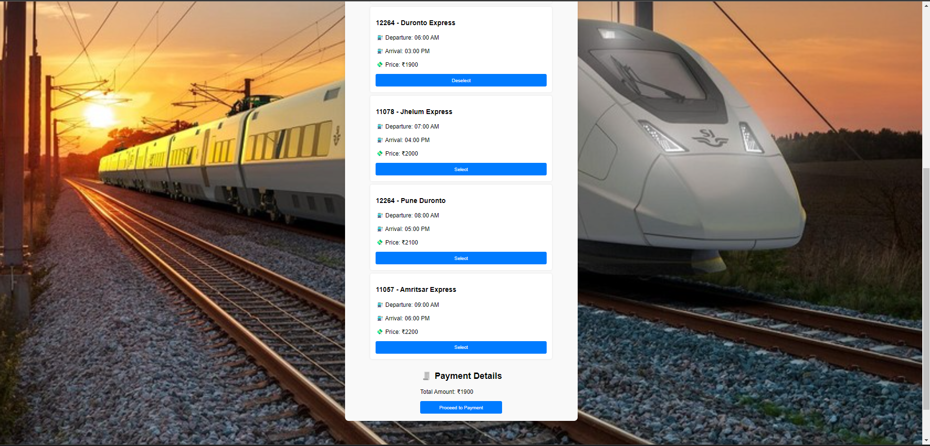

**Buses:**

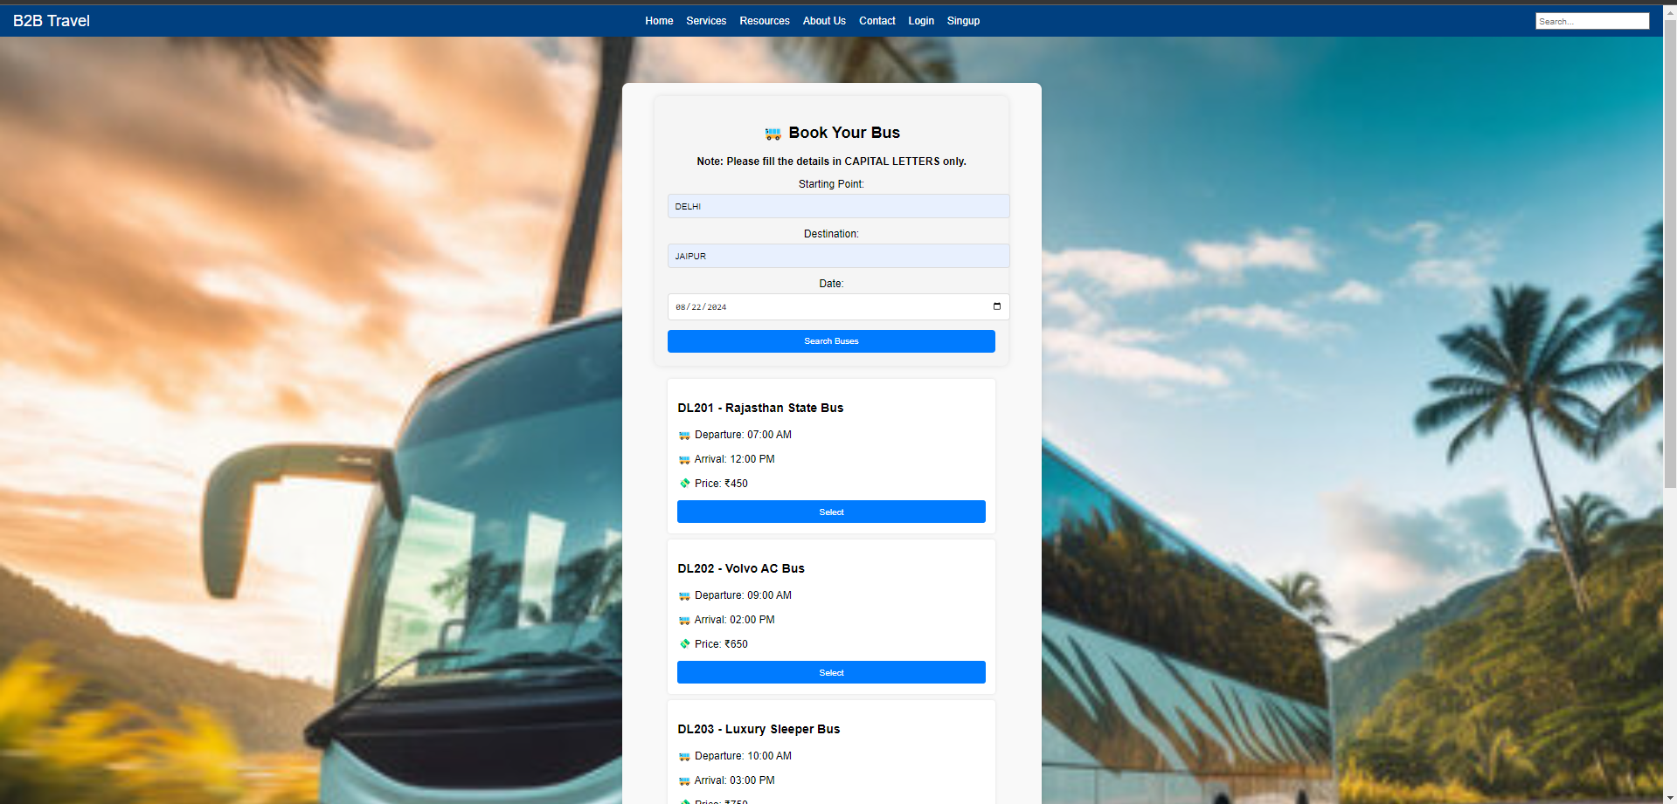

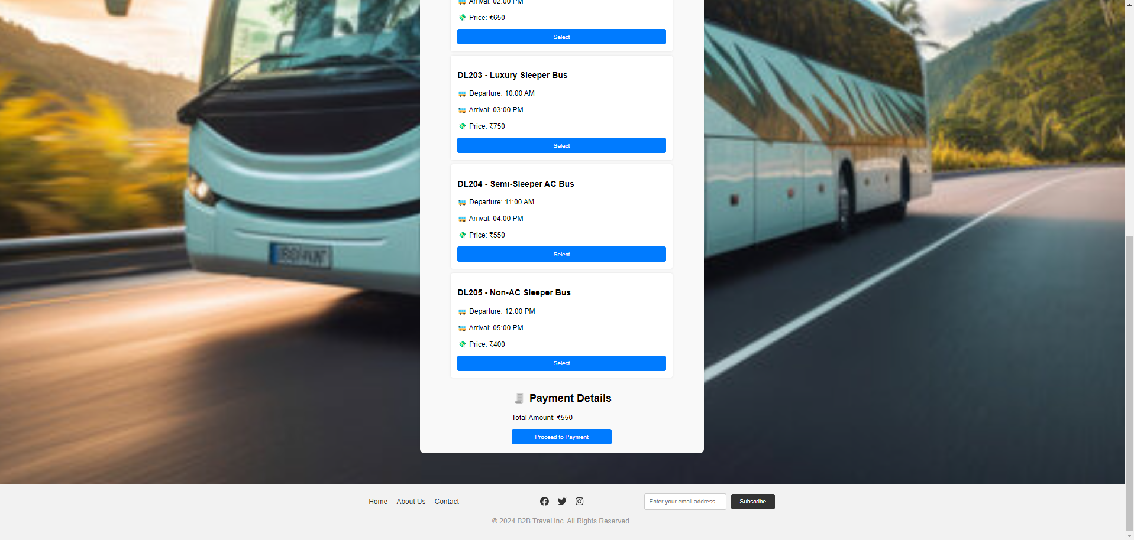

**Cabs:**

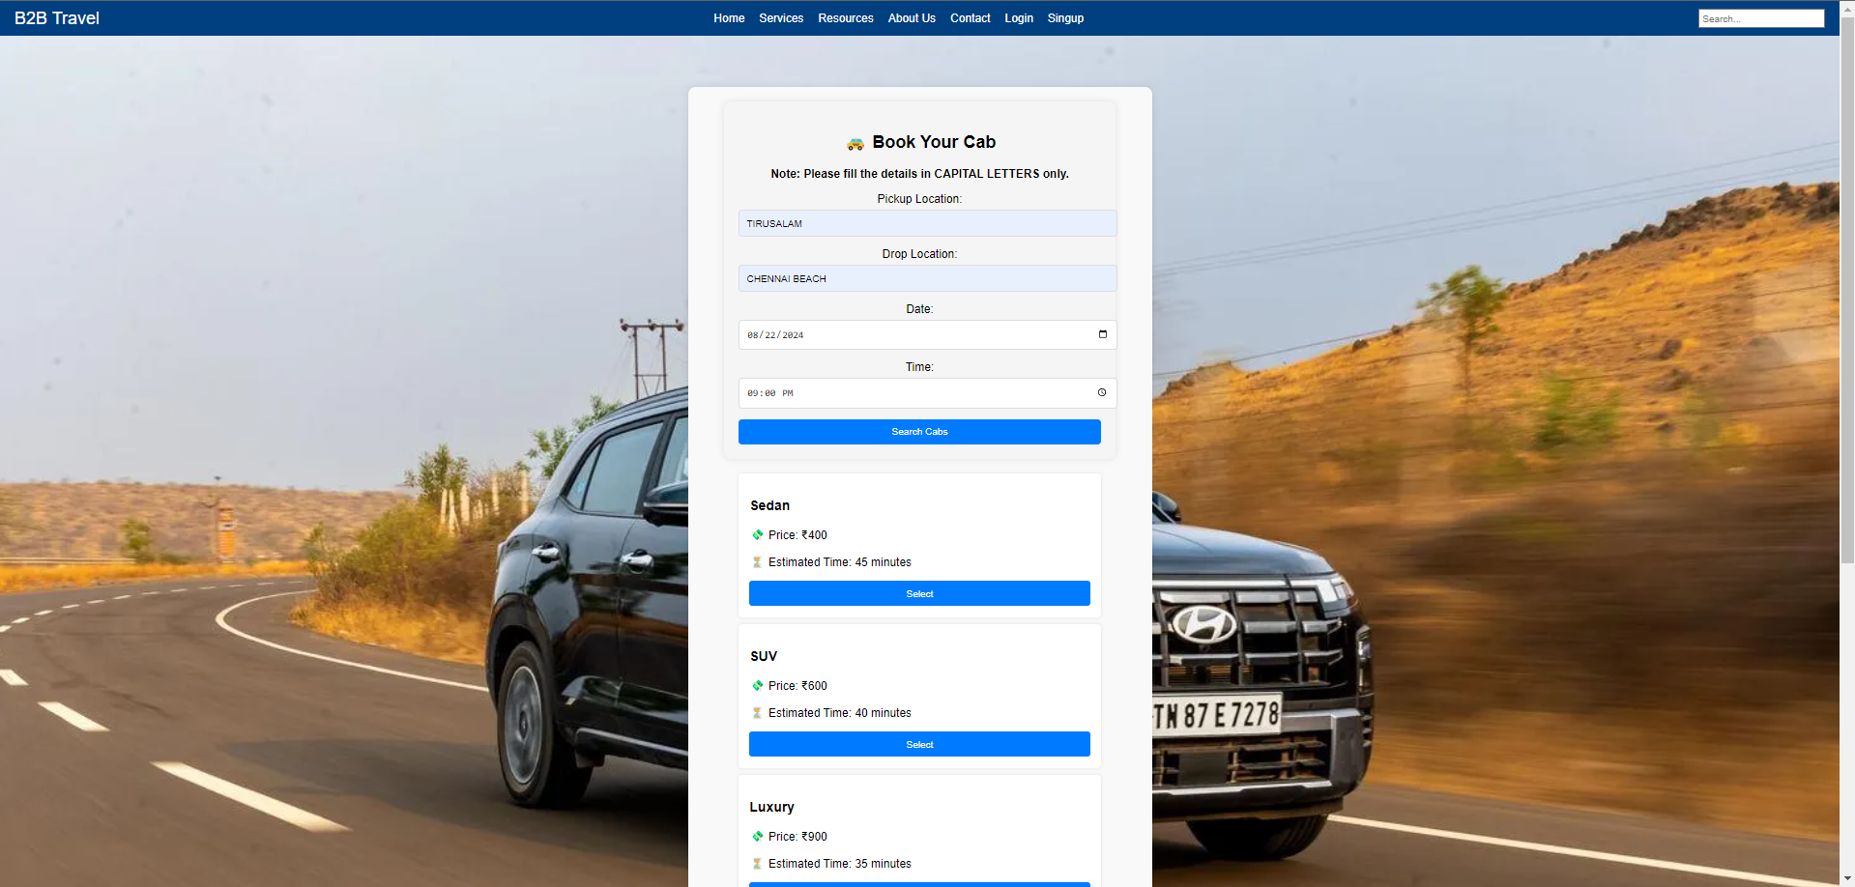

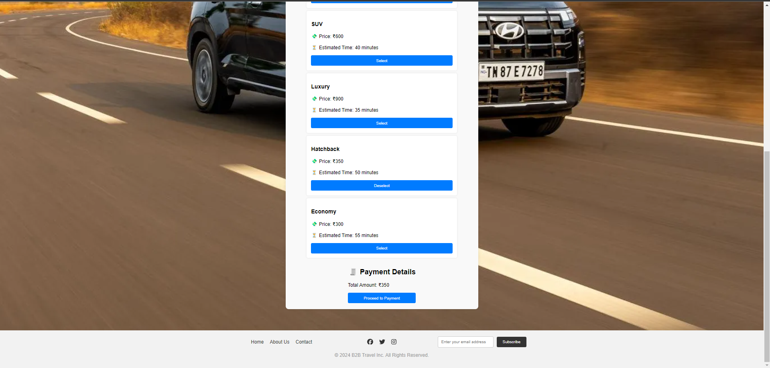

**Hotels:**

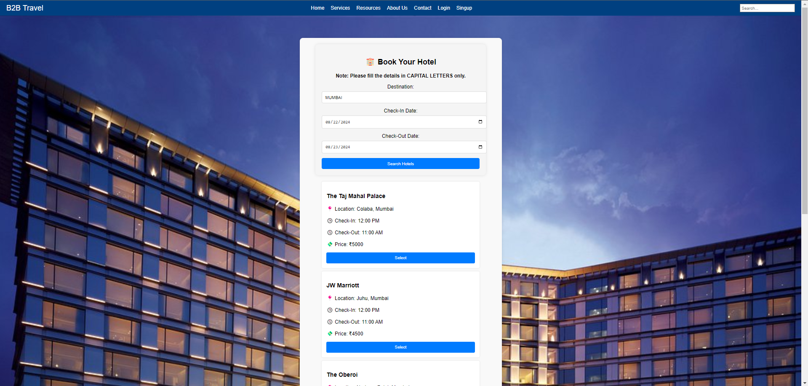

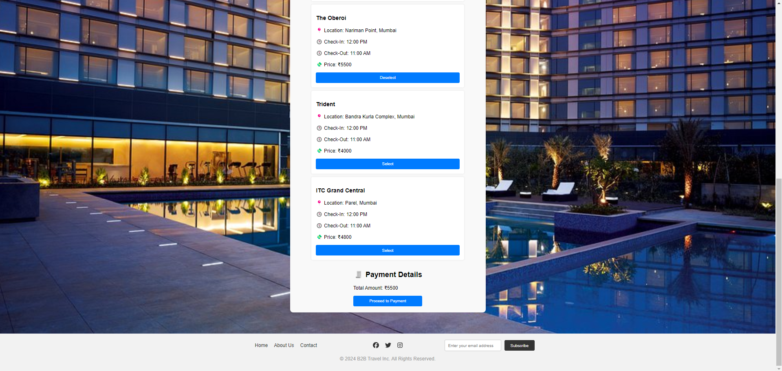

**Here’s the complete website, if you say then I will deploy it through firebase and the GitHub repository link of the website is shared below:**

**GitHub:** [**https://github.com/mishraji874/B2B-Travel-Compnay**](https://github.com/mishraji874/B2B-Travel-Compnay)

**Aditya Mishra**

[**Jobs.adityamsr@gmail.com**](mailto:Jobs.adityamsr@gmail.com)

**+916393246930**

**https://autumn-haze-7462.on.fleek.co/**